**Weekly report (first week after Easter)**

**All graph are at the end**

Ran more thorough analyses of shuffling, normalisation, and effects of having many filters per layer as well as many layers. Need to analyse further the effects of max. pooling.

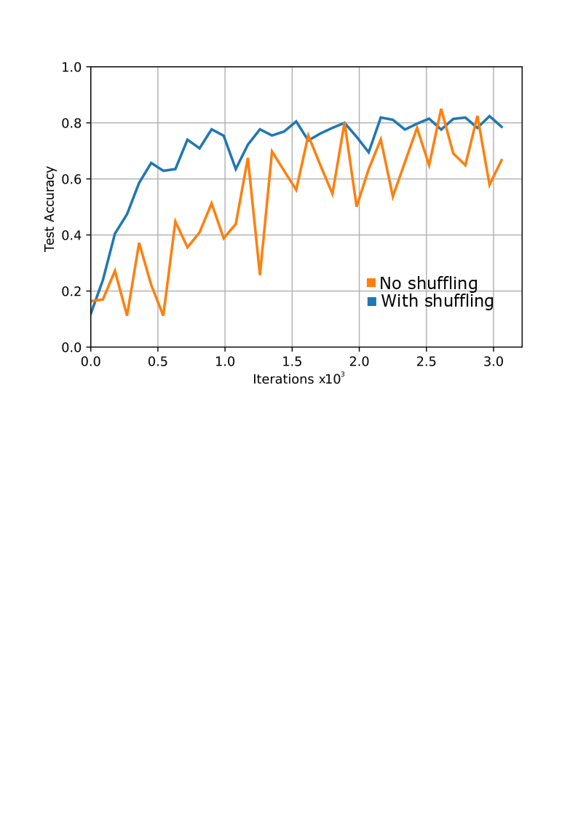

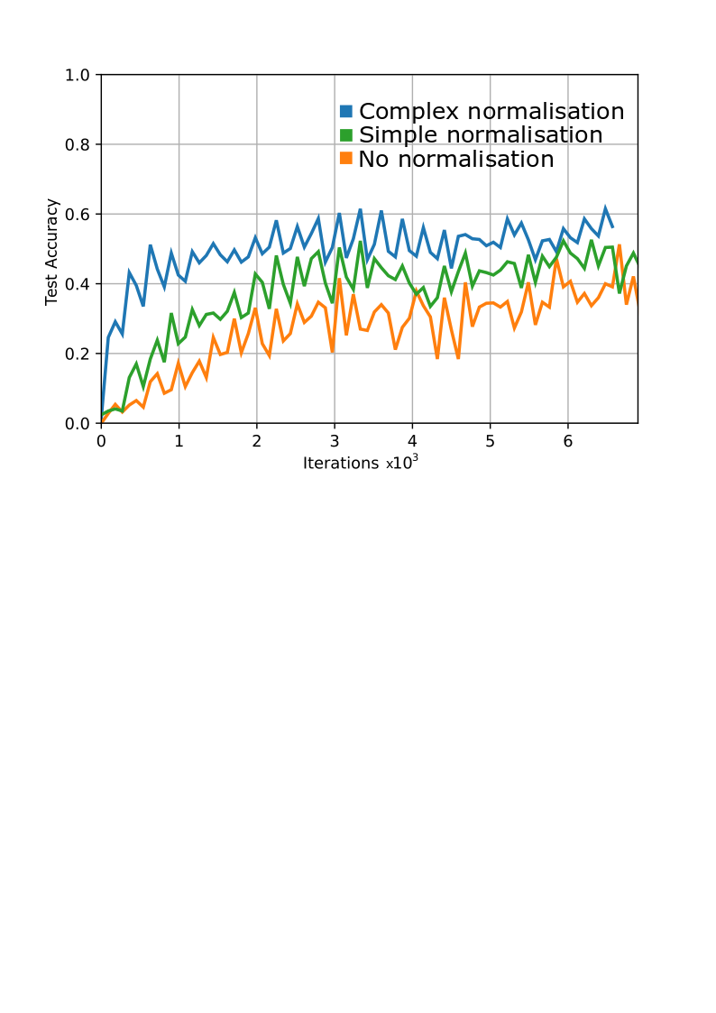

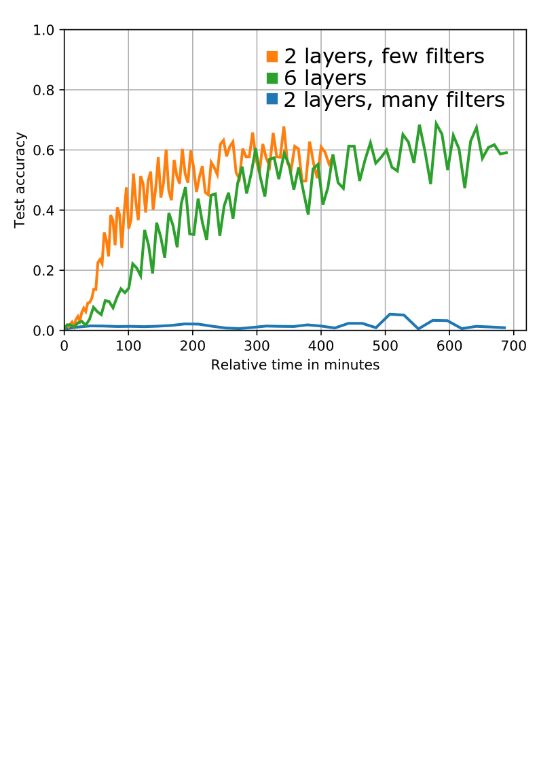

Hongming has provided us with a transcript of the Baotu Spring poem. Used Open-CC online to turn the traditional Chinese characters to simplified Chinese.

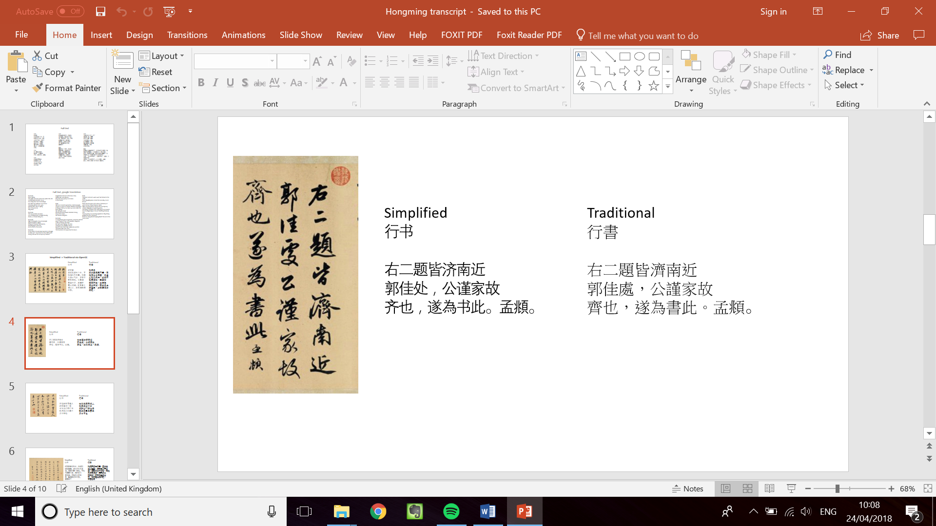

The CASIA database has simplified Chinese only, whereas Baotu Spring consists of traditional Chinese.

Ran feature map analysis again, for some reason it was far more detailed this time. Also wrote code to generate activations for a 4 layer and 6 layer network, as well as to output the weight filters.

*Feature maps from CASIA (1st layer)*

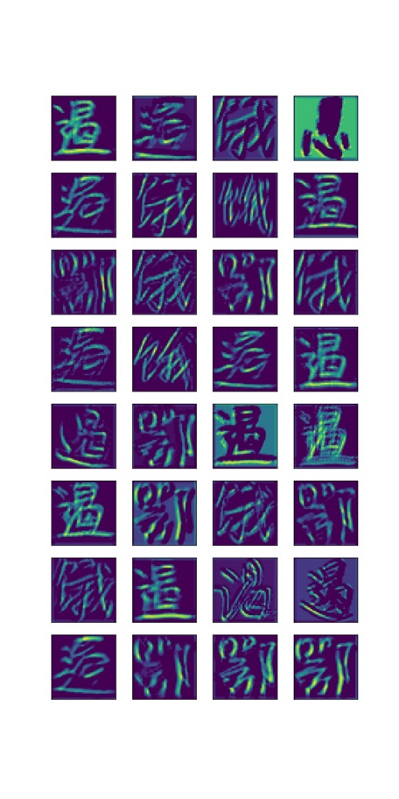

*Feature maps from calligraphy (1st layer)*

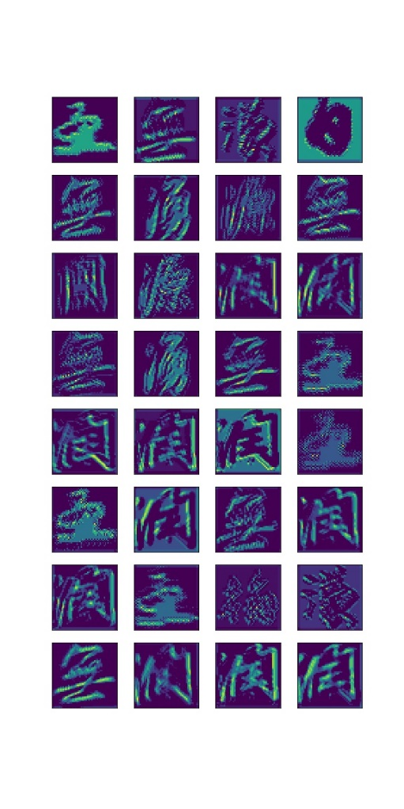

*Feature maps from CASIA (2nd layer)*

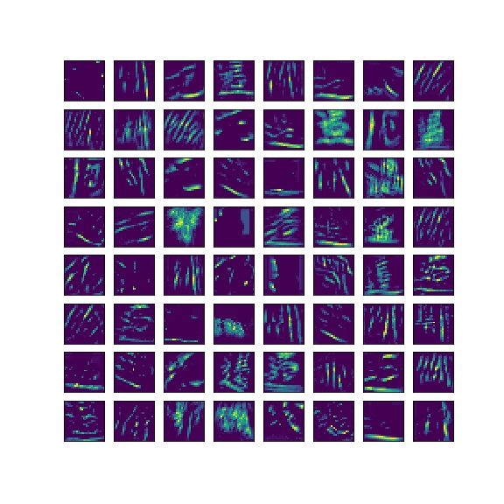

*Weights maps from CASIA (1st layer)*

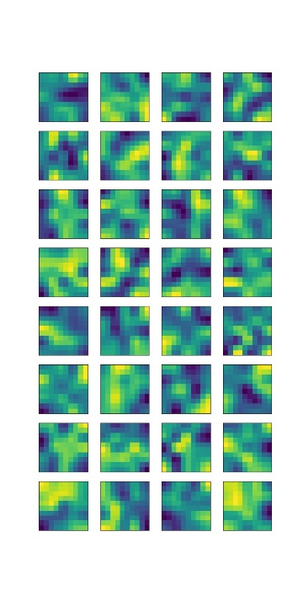

Normalised the segmented calligraphy characters, compiled them into a .tfrecord and tested featuremaps on them.

**Action points for the next week**